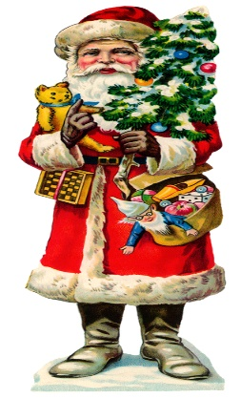

Our World Around Us topic is “In the Toy Box”. We will try to answer these questions:

What materials are toys made from?

How have toys changed over time?

What sources of energy do toys use?

What toys do we use outside?

How can we play safely with toys?

# Number

## All children should be confident using their number stories to 5. Count to 50 and beyond.

## Practise writing numbers to 20, ensure the formation is correct. Continue to count in 2’s, 2-20 and 1-19. Count in 5’s to 50 and 10’s to 100. Discuss odd/even numbers. Recognise double and half numbers. All these can be found at the back of your child’s homework diary.

Shape

Look for 3d shapes all around. Discuss cubes, cuboids, cylinders, spheres and cones.



The Christmas Rickety Wheel is on Thursday 5th December

5-8pm

**Important Dates**

* Open Afternoon – Tuesday 3rd December 2.00-3.00
* P2 – P4 Christmas show in the assembly hall

7 pm Monday 9th December.

1:15 pm Tuesday 10th December.

* School Closed for elections – Thursday 12th December.
* Carol Service –

Our Lady of Lourdes Church -

11 am Tuesday 17th December.

Phonics

Continue to make small words using all letters of the alphabet. Try to build up word families, it, bit, sit, lit etc. Find words that rhyme e.g. bat and cat. Find rhyming words in daily reading book. Talk about syllables in words and clap them out e.g. holly – hol + ly = holly, 2 claps.

Year 2

Nov/Dec



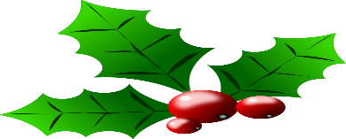

blockpage[1]

All children will be performing in the Christmas show. We will be asking parents for help with their child’s costume. More details will follow.

Measures

We will be exploring weight and developing appropriate mathematical language, heavy/light, heavier/lighter, heaviest/lightest, balance, same as etc.

Christmas

The school will close on Friday 20th December at 12.30 and will reopen on Monday 6th January. Dinner will be served before dismissal on Friday 20th. We wish you all a very Happy Christmas and a peaceful New Year.