Monday News 6th April 2026
Dates for your Diary
Fri 3rd April – Mon 13th April School Closed – Easter Holidays
All pupils return Tues 14th April

Tues 14th April   | Credit Union Savings will be collected Tues this week only  P1: Ballymoor - Football Skills Wk 1/6  P2: Musical Pathways-Every Week- During School  Tryatrie - Week 3/4  9.45-1.15pm: Nursery to visit Playtrail  2-3pm: P7 Cycling Profiencey Course Wk 2/12 Wed this week only
Wed 15th April   | P3A & P5: Na Magha- Hurley – Every Week -During School  Jazz festival participants to visit school  2-3pm: P7 Cycling Profiencey Course Wk 2/12. Wed this week only  7pm: Smartphone Information Session- Shantallow Community Centre.  Parents encouraged to attend
Thurs 16th April | P4 & P5: Mandarin Lessons – Every Week – During School  No Brass Lessons this week  9.15am: Families Connect Coffee Morning- Library  10am: Whole School Mass -Our Lady of Lourdes.  P5 & P6 Confessions afterwards
Fri 17th April | Breakfast Club Specials – Every Friday
Wed 22nd Apr | 12.30-3pm: Netball Competition/No Netball Afterschool Club
Fri 24th Apr | 9.10am: Mrs Cooke’s P2 class Assembly. Families welcome to attend
Thurs 30th Apr 6.30pm   | Community Bingo- Snow Ball supported by Shantallow Mens Group
Sat 16th May  | 12 Noon: P4 First Holy Communion – Our lady of Lourdes Church
Mon 15th June | School Closed - Staff Development Day
Tues 30th June | Half day for all pupils
Dinner Menu
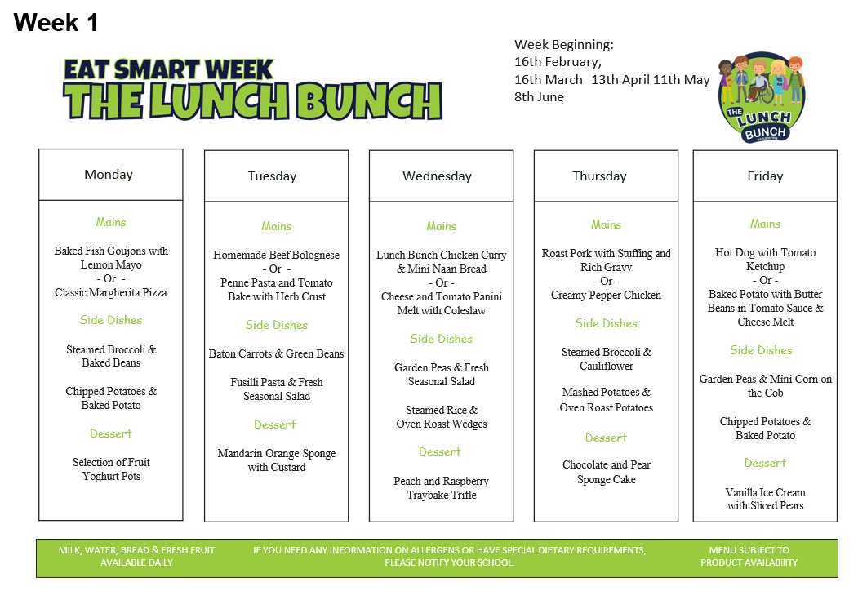

Trócaire
Thank you to all parents & pupils for supporting our Trócaire Lenten fundraisers for each Year Group. All monies raised will be presented after the easter holiday.
We greatly appreciate your support in helping us raise funds or this very worthy cause.

Crack the Egg Winner
Congratulations to Mr & Mrs Mclaughlin, grandparents of Jack P3, who won our 'Crack the Egg' Draw. Thank you to everyone who bought tickets to support school funds.
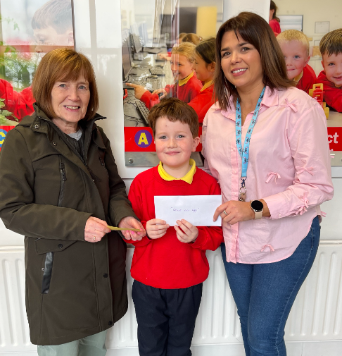
Easter Raffle Winners
Congratulations to all our lucky winners: Riley (P4), Carter (P3), Clodagh (P5), Logan (SPIMS 2)
Thank you to everyone who purchased tickets – all monies raised go towards school funds.
Thank you to Carter(P3) & Maddison’s (P6) Granny for her kind donation of a beautiful Easter Hamper for our Raffle. Thank you to Gimme Goodies, Richmond Centre & Monto Chocolates for their kind donation towards our raffle. We greatly appreciate your support.
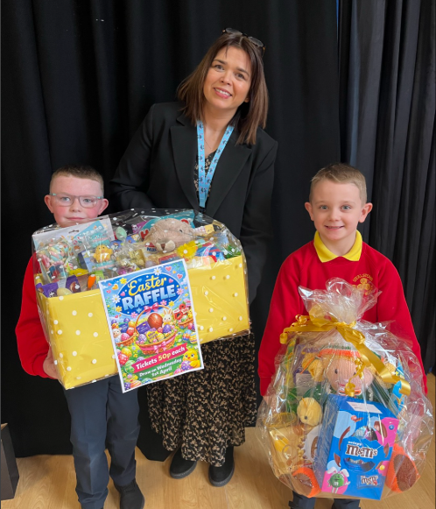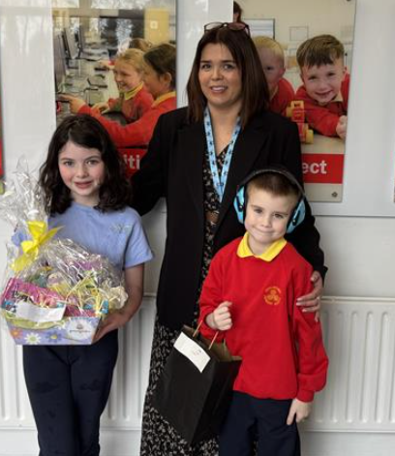
Smartphone Free Childhood- Parent Information Session
We encourage all parents to attend this worthwhile information session, please register your interest via the form sent via Just2Easy.
