Monday News 20th April 2026
Dates for your Diary
Mon 20th April | ***Dinner Menu. Week 2 Dinner Menu (Copy on website/paper copies available at Office)  Credit Union savings day  P3’s, P7’s & P5C: Brian Ogs Gaelic - During School  SPIMS 3, 7A & 7B: Swimming at City Baths during School (10 wks)
Tues 21st April   | P1: Fundamental Football Skills with Ballymoor - During School (6 weeks)  P2: Musical Pathways-Every Week- During School  Try a Tri : Week 4/4  3-4pm: P6 Transfer Club- Every Tues & Thurs
Wed 22nd April   | P3A & P5: Na Magha- Hurley – Every Week -During School  12.30-3pm: Netball Competition- Foyle Arena (NO Afterschool Netball)
Thurs 23rd April | P4 & P5: Mandarin Lessons – Every Week – During School  P5-P7: Brass Lessons resume, please bring instrument  10am: Whole School Mass- Our Lady of Lourdes Church  12-1pm: P7A Mrs O’Donnell- E.A Youth service Transfer workshops, Shantallow Community Centre  1.40-2.50pm: P7B Mr Feeney’s Class- E.A Youth service Transfer workshops, Shantallow Community Centre  3-4pm: P6 Transfer Club- Every Tues & Thurs
Fri 24th April | 8.15-9am: ‘Breakfast Club Special’ Every Friday  9.10am: Miss Cooke’s P2 Class Assembly  Caina healy Children’s Try a Tri
Mon 27th April | 9am: Current P4’s: Online Registration for Instrument for Sept opens (Closes 1st May 5.00pm)
Thurs 30th April | 2.30pm: Nursery induction meeting for parents for new Nursery pupils in September  6.30pm: Community Bingo. Everyone Welcome
Fri 1st May | 9.10am: Miss McGregor’s P6 Class Assembly  5pm: Current P4’s: Online Registration for Instrument for Sept closes
Mon 4th May | School Closed- Bank Holiday
Wed 6th May | 6.30pm: P1 Induction meeting for parents for P1 pupils in September
Fri 8th May | 9.10am: Ms Mallons P4 Class Assembly
Sun 10th May | 12.15pm: P4 DTIM Mass
Tues 12th May | Whole School Zumbathon – More details to follow
Sat 16th May  | 12 Noon: P4 First Holy Communion – Our lady of Lourdes Church
Mon 25th - Fri 29th May | School Closed- May Holiday
Sun 7th June | 12.15pm: P4 DTIM Mass- Corpus Christi
Mon 15th June | School Closed - Staff Development Day

Daily Sandwich Option – Parent Information
As part of our daily canteen menu, we are pleased to announce that, beginning Monday 20th April, children can choose a daily sandwich option — White Bread with ham/butter or tuna/mayo. If your child would like a sandwich, they must inform their teacher on the morning of the day they would like it.
If a sandwich is not ordered with their teacher in the morning, your child will need to choose from the normal menu for that day.
All children can avail of this option. The usual accompanying sides and dessert will also be available.
Dinner Menu
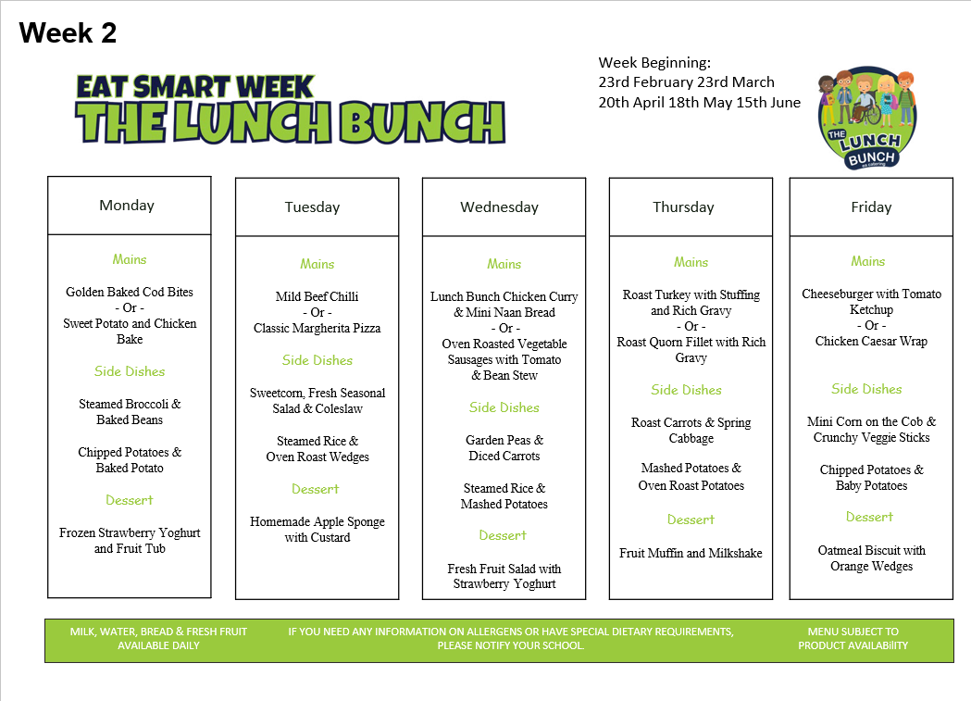

Sports Day
Please note dates are provisional/weather permitting & subject to change
Mon 18th May | P1
Tues 19th May | P2
Wed 20th May | P3
Thurs 21st May | P4
Wed 10th June | P5-P7 Brian Og’s Gaelic Pitch

Uniform
As we near the end of the school year, can we ask that children still maintain our high standards & wear full school uniform. Children are now welcome to wear summer uniforms. Logo shorts, cycling shorts & leggings are not permitted.
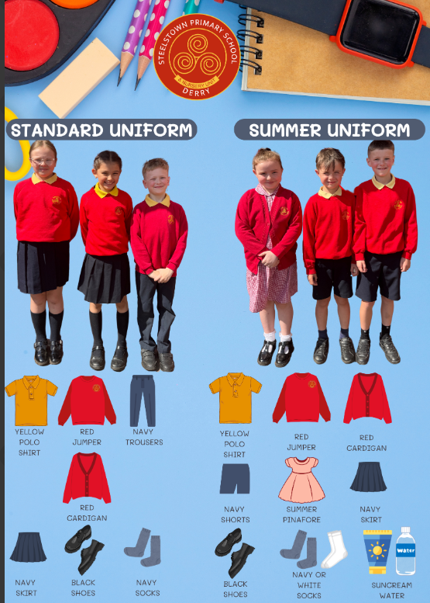
Community Bingo
Our ever-popular Bingo takes place on Thursday 30th April – with amazing cash prizes to be won!! 💰
⭐ Snowball sponsored by Shantallow Men’s Support Group
🎟️ Bingo Books: £10 (Pre-book at the school office, books will be given out on the night)
📞 To reserve your place, please call the office on 71351830
🎁 We would also greatly appreciate any raffle donations, including vouchers, wine or unwanted beauty items.
Thank you for your continued support – we look forward to seeing you there! 😊
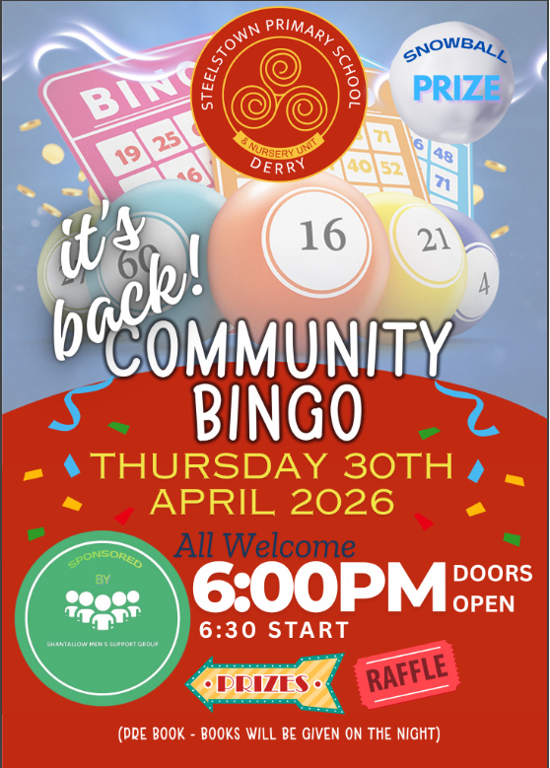
Smartphone free Childhood
Thank you to everyone who attended the Smartphone-Free Childhood presentation with Dr Claire Sinton, a Paediatric Consultant and the Head of Smartphone-Free Childhood Derry. It was encouraging to see so many families and local schools come together to discuss one of the most important issues facing children and families today. This event marks the beginning of our journey as a school community—opening conversations, sharing insights, and exploring how we can work together to better support our children’s well-being.
If you were unable to attend, please see the information below, which we hope you will find helpful and informative.
Families can also explore the broader context here: https://www.smartphonefreechildhood.org/the-issue/problem

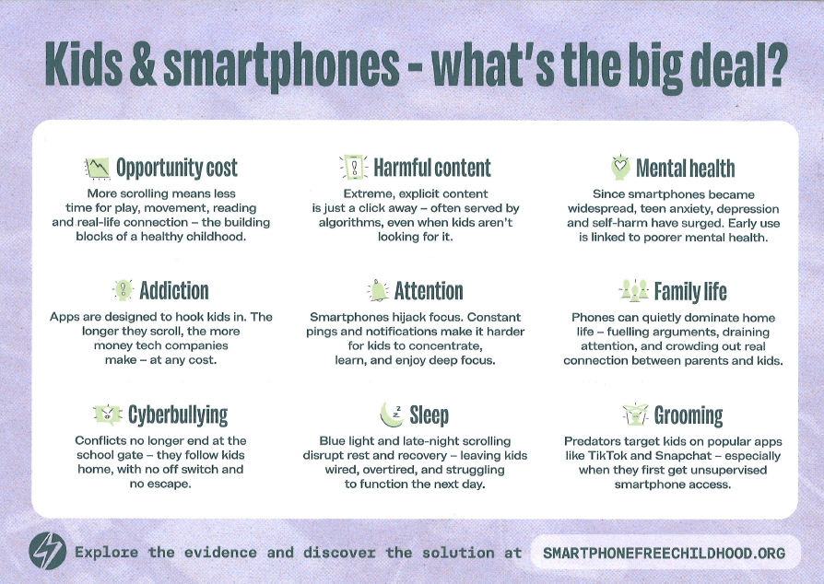
Friends of Steelstown – Volunteers needed
We are seeking volunteers to join ‘Friends of Steelstown’ and help establish a small working group to support upcoming fundraising events — including BINGO!
It’s a great way to get involved, meet others, and have fun. If you or someone you know would like to join, please contact the school office. Participation is open to all friends of Steelstown, not just carers and families.
Singing Lessons
