Monday News 4th May 2026
Dates for your Diary
Mon 4th May | School Closed - May Bank Holiday  No Credit Union Collection this week- next savings day is Monday 11th May
Tues 5th May   | P1: Fundamental Football Skills with Ballymoor - During School (6 weeks)  P1: Musical Pathways-Every Week- During School  3-4pm: P6 Transfer Club- Every Tues & Thurs
Wed 6th May   | P3A & P5: Na Magha- Hurley – Every Week -During School  12 – 2.30pm: Netball Tournament, Foyle Arena.  (No Netball Afterschool)  2-3pm: P7 Cycling Profiencey Course (Week 5/12)  Bike & Helmet needed each week  6.30pm: P1 Induction meeting for parents for P1 pupils  in September
Thurs 7th May | P4 & P5: Mandarin Lessons – Every Week – During School  P5-P7: Brass Lessons resume, please bring instrument  10am: Whole School Mass  3-4pm: P6 Transfer Club- Every Tues & Thurs
Fri 8th May | 8.15-9am: ‘Breakfast Club Special’ Every Friday  9.10am: Ms Mallon’s P4 Class Assembly.  Families welcome to attend
Sat 9th May | P7 pupils receive Post Primary outcome
Sun 10th May | 12.15pm: P4 DTIM Mass- Second Sunday of May
Tues 12th May | Whole School Zumbathon – More details to follow
Wed 13th May | 1.30-3pm: Parents Workshop with Numerasee. Please return note confirming attendance
Sat 16th May   | 12 Noon: P4 First Holy Communion – Our lady of Lourdes Church. Photographer available before & after mass.
Fri 22nd May | 9.10am: Mrs Tierney’s P4 Class Assembly
Mon 25th - Fri 29th May | School Closed- May Holiday
Fri 5th June | 9.10am: Mrs Warren’s P2 Class Assembly  10 – 1.30pm: P7 Fan the Flame Mass
Sun 7th June | 12.15pm: P4 DTIM Mass- Corpus Christi
Thurs 11th June | NWSSA- Swim Gala- City Baths
Mon 15th June | School Closed - Staff Development Day
Wed 17th June | 9.15-11.30am: Nursery- visit Playtrail, Forest Schools  2pm: P7 Leavers Mass, Our Lady of Lourdes Church
Tues 30th June | Non-uniform day & 12.30pm finish for all pupils


Summer Term Reminder
As we enter the summer term, we kindly ask that all items such as jumpers, cardigans, coats and water bottles are clearly labelled with your child’s name to help prevent items being misplaced.

On warmer days, please remember to apply sun cream before your child comes to school.
P4 First Communion- Photograph
The school photographer will be available before & after mass to take individual/family photos.
Please only have photos taken if you are committed to buying.
E-Sports Wed’s P4-P7
E- Sports After school club begins Wednesday 6th May & will run every Wednesday for P4-P7 pupils from 3.05-4pm.
Unfortunately, only 10 places are available. If you would like your child to attend, please complete the Afterschool Permission Form on the School Website.
Places are on a first come basis due to limited numbers and you can only sign up using the online form. The 10 successful pupils & parents will be notified by Tuesday 5th May.

Sports Day
Please note dates are provisional/weather permitting & subject to change
Mon 18th May | TBC | P1
Tues 19th May | TBC | P2
Wed 20th May | 9.30-12pm | P3
Thurs 21st May | 10am-12pm | P4
Wed 10th June | TBC | P5-P7 Brian Og’s Gaelic Pitch


End of year trips
All pupils will receive a permission note for their end of year trip in the coming weeks. Please return the permission slip & monies to class teacher.
P1 | 18th June | Oakfield Park, Raphoe
P2 | 18th June | Lurgybrack Farm, Letterkenny
P3 | 16th June | Wild Ireland
P4 | 19th June | Leisureland, Redcastle
P5 | 24th June | Lock ‘N’ Load
P6 | 22nd June | Lifford Courthouse
P7 | 22-24th June | Carlingford

Well Done
Well done to Mr Morroi, Classroom Assistant, who won Heavyweight Gold at the IBJJF Dublin International Open!
What an incredible achievement – we are so proud of you!


Numeracy Parent Workshop
Would you like to support your child’s learning in maths?
Join us for our upcoming Numeracy Workshop delivered in partnership with Katrina from Numerasee. Please return your attendance slip when you receive it to secure your place!
We strongly encourage all parents to attend this informative and practical session – it’s a great opportunity to pick up tips and ideas to support your child at home.

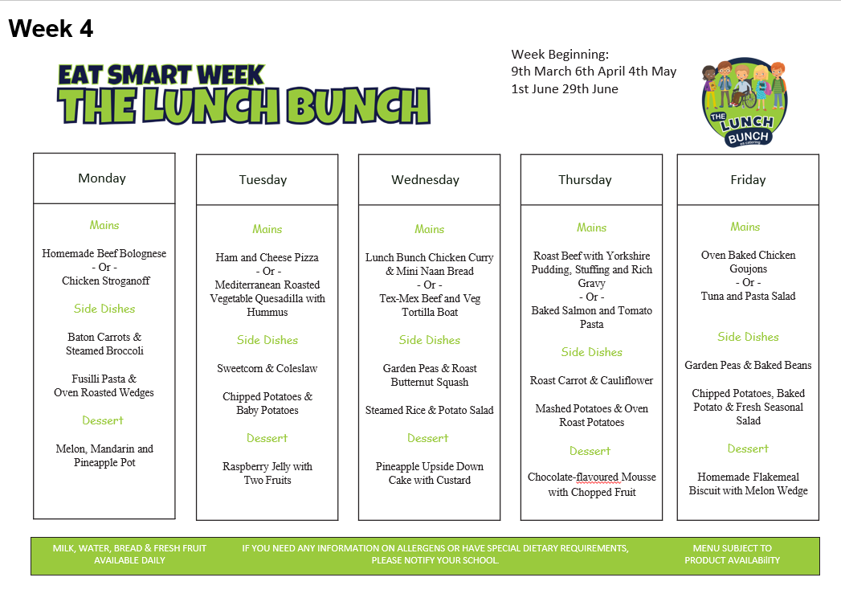
Best of Luck
A huge good luck to Mrs McCaul as she takes part in the Belfast Marathon this weekend.
From everyone at Steelstown P.S., we are so proud of you and will be cheering you on every step of the way!




