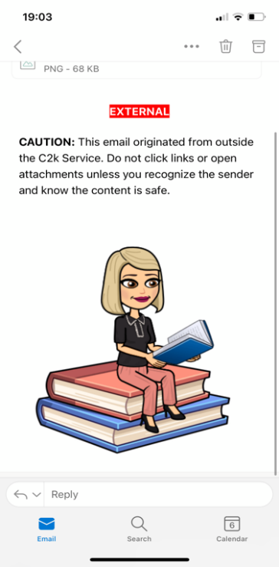

**School Day**

A reminder that our school day has slightly changed, in line with the current circumstances. Primary 5’s adapted times are:

8:45am – school starts

Children may come straight up their designated stairwell and into their class where their teacher will be.

2:50pm - school day ends.

**Mathletics**

Children are encouraged to use their individual log-ins to play Mathletics at home to reach their weekly target set that week. Mathletics can be accessed on desktop computers or tablets. Children can also access Mathletics each day once their school work is completed, in order to boost their mathematical fluency.

**Homework**

Please ensure your child’s written homework and Homework Diary is signed each night, once homework is sent home. Encourage your child to read to an adult and discuss the content of the book and the characters. **Please practise mental maths and spellings each night in preparation for Friday’s tests.**

**Physical Education**

Children should come to school wearing their P.E. gear on their set day for P.E. Teachers will let children know in advance when P.E. is. Children should wear appropriate P.E. gear depending on the weather.

**Healthy Eating & Nut Awareness**

A reminder that Steelstown Primary School is a health promoting school and has a healthy breaks policy. We also currently have a pupil in the school with a severe nut allergy. Please ensure that your child has **no nut products** in their lunchboxes.

September 2021

Year 5 Newsletter

**Accelerated Reading**

Each child is encouraged to read for pleasure as much as possible in order to develop their inferencing skills. Accelerated Reading will remain a big focus across the school this year. Children will receive incentives once they have reached certain targets.

**Water**

Our first World Around Us topic is Water. The children will be learning about where they can find water in our bodies and plants, different types of water, the water cycle and look at the various different rivers around us. Children are encouraged to discuss these themes at home and look out for any interesting water features around them!