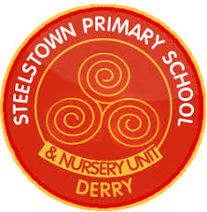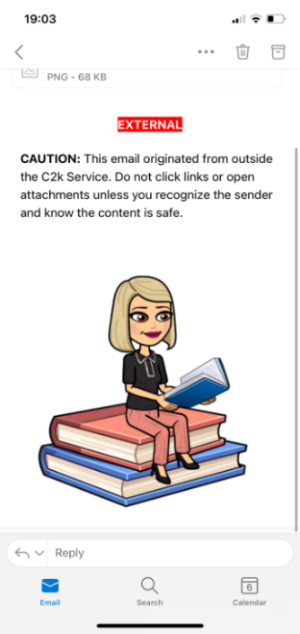

**Many Thanks,**

**Mrs O’Hara and Mr Lowry**

**Literacy**

This term P5 children will be continuing to focus on using their comprehension skills to ensure they understand what they are reading. Please talk to your children and ask them questions about their reading book. We will also be exploring homophones, plurals, proper nouns, contractions and commas.

**Catholic Schools Week & Grandparents Day**

Catholic Schools Week begins on the 29th of January and continues until the 4th of February in the Diocese of Derry. The theme for this year is ‘Catholic Schools: Walking Together in Faith and Love.’

Grandparents Day will be celebrated with Mass on Wednesday 1st February in Our Lady of Lourdes at 10am. Grandparents are invited to the school afterwards for refreshments.

**Numeracy**

This term P5 will be continuing with learning times tables and related division facts. We will also be exploring money, fractions, 24hr time, area, and 3D shapes. Please try to give your child as many opportunities as possible to use their mathematical skills in real life situations.

**Homework**

Please ensure your child’s written homework and reading record is signed each night. Encourage your child to read to an adult and discuss the content of the book and the characters. Please practise mental maths and spellings each night in preparation for Friday’s tests. Please ensure your child is getting a minimum of 500 points on Mathletics.

January 2023

Year 5 Newsletter

**Accelerated Reading**

Each child is encouraged to read for pleasure as much as possible in order to develop their inferencing skills. Accelerated Reading will remain a big focus across the school this year. Children will receive incentives once they have reached certain targets.

**PE**

P.E will be on Fridays, a member of Steelstown Brian Ogs will be in teaching Gaelic skills this term.

Children should wear their yellow polo top and school jumper with navy jogging bottoms and trainers. Please send a bottle of water.

**Healthy Eating & Allergy Awareness**

A reminder that Steelstown Primary School is a health promoting school and has a healthy breaks policy. We also currently have pupils in the school with severe nut, egg and kiwi allergies. Please ensure that your child has **no nut, egg or kiwi products** in their lunchboxes.

**Egyptians**

Our topic this term will be on Ancient Egypt. This will cover a wide variety of learning including the geography of Egypt and famous landmarks, the chain of command, mummification, tombs and what was found in them, famous Kings, Queens, Pharaohs, Gods and Goddesses. The children will take part in fun learning experiments.